Project Design Phase-II Technology Stack (Architecture & Stack)

Date: | 10/02/2026
Team Id: | LTVIP2026TMIDS25023
Project Name: | Measuring the Pulse of prosperity: An index of economic freedom analysis
Maximum Marks: | 4 Marks

Technical Architecture:
The Deliverable shall include the architectural diagram as below and the information as per the table1 & table 2

Component | Description | Technology
User Interface | How user interacts with application e.g. Web UI, Mobile App, Chatbot etc. | HTML, CSS, JavaScript / Angular Js / React Js etc.
Application Logic-1 | Logic for a process in the application | Java / Python
Application Logic-2 | Logic for a process in the application | IBM Watson STT service
Application Logic-3 | Logic for a process in the application | IBM Watson Assistant

Database | Data Type, Configurations etc. | MySQL, NoSQL, etc.
Example: Order processing during pandemics for offline mode
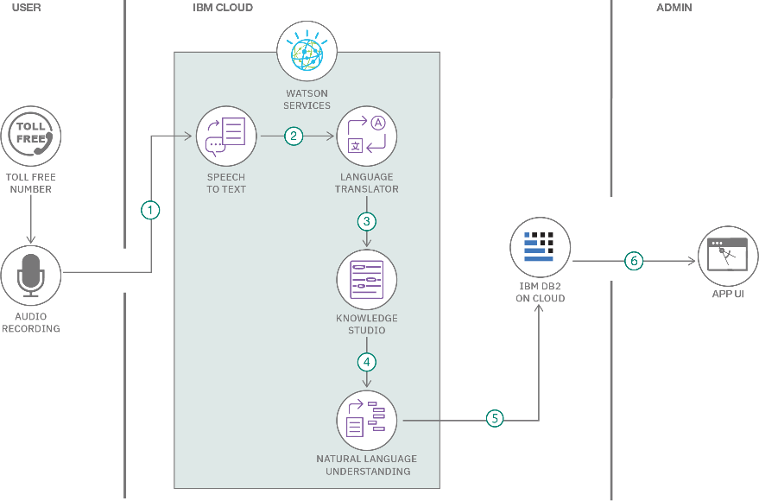

S.N  o | Characteristics | Description | Technology
1. | Open-Source Frameworks | List the open-source frameworks used | Technology of Opensource framework
2. | Security Implementations | List all the security / access controls implemented, use of firewalls etc. | e.g. SHA-256, Encryptions, IAM Controls, OWASP etc.
3. | Scalable Architecture | Justify the scalability of architecture (3 – tier, Micro-services) | Technology used
4. | Availability | Justify the availability of application  (e.g. use of load balancers, distributed servers etc.) | Technology used
5. | Performance | Design consideration for the performance of the application (number of requests per sec, use of  Cache, use of CDN’s) etc. | Technology used
Table-1 : Components & Technologies:

Table-2: Application Characteristics:

Cloud Database | Database Service on Cloud | IBM DB2, IBM Cloudant etc.
File Storage | File storage requirements | IBM Block Storage or Other Storage Service or Local  Filesystem
External API-1 | Purpose of External API used in the application | IBM Weather API, etc.
External API-2 | Purpose of External API used in the application | Aadhar API, etc.
Machine Learning Model | Purpose of Machine Learning Model | Object Recognition Model, etc.
Infrastructure (Server / Cloud) | Application Deployment on Local System / Cloud  Local Server Configuration:  Cloud Server Configuration : | Local, Cloud Foundry, Kubernetes, etc.

